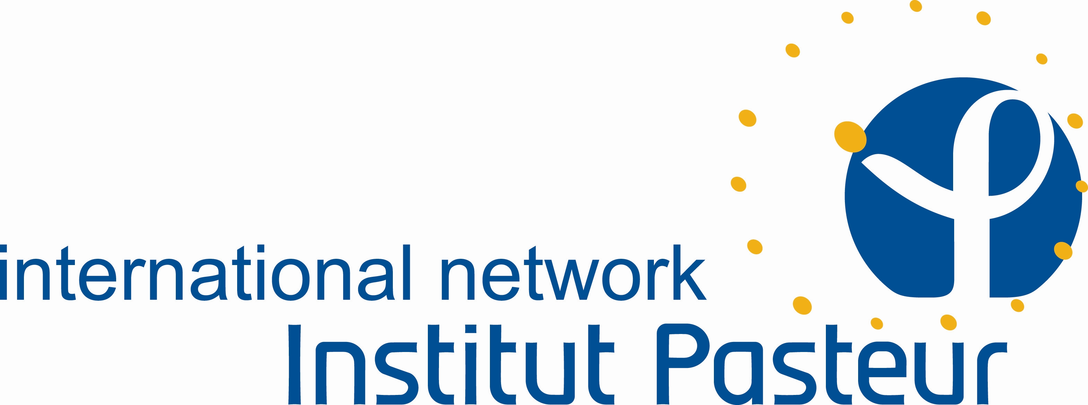

5th International course on Viruses and Human Cancers
08 July -13 July 2019
Institut Pasteur of Roma, Italy

APPLICATION FORM
First name:
Last name:
Gender: | ☐M ☐F
Position: | ☐Research Scientist ☐Post-doc ☐PhD Student ☐MSc Student
Affiliation:
Department:
Address:
Country: |  | City: | Postal code:
E-mail: |  | Phone Number:
Level of English: | ☐Low ☐Intermediate ☐Advanced ☐Proficient

Application form with a CV and a letter of motivation must be sent by e-mail to:

application@istitutopasteur.it

The call is open to scientific and medical students, Master, PhD, MD and Postdoctoral researchers.

The course will finance accommodation with breakfast, lunches and coffee breaks.
The flight ticket and dinners will be at your own expense.

The committee of the course will evaluate applications

The deadline for application is May 1st, 2019.

